Grade 5
Earth Approach: Slope Matters

Description: | Students will:  Create a script that moves a spaceship to a given location.  Use x/y increase by to control the spaceship’s speed and direction  Lear to estimate the angle needed for the landing path’s slope.  Express estimates as a ratio of rise over run.  Experiment with positive and negative values for rise and for run.  Experiment with ratios; e.g. 2:4 as 4:8.  Use scale factor to adjust the size of the spaceship and landing zone.  Experiment with decimals such as 0.5, 0.05 and 0.005 as scale factors.  Create a Reset script with x and y locations for the spaceship and Earth.  Add random number generator tiles to the reset script.  Control the range of random number generators in their scripts  Create a Challenges script that changes locations and sizes.  Make a flap with information about their project.  Consider aesthetics; colors and designs to make a harmonious whole.
Project View | 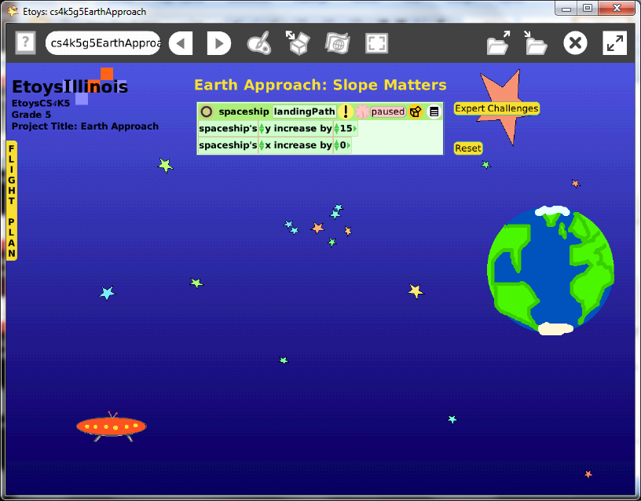
Subject: | Mathematics, Science
Etoys Quick Guides | Click the question mark in Etoys to open the set of interactive tutorials for basic tools and techniques.
Vocabulary: | Graphing points on the coordinated plane, slope, rise over run, x increase/ decrease by, y increase/decrease by, scale factor, fractions, decimals, random number generator, conditional statements, estimate, ratios
Lesson 1:  Paint Tools: Brushes  Script Tiles: X and Y Tiles  Script Tiles: Exact Location  Navigator Bar: Keep Find Projects | Each lesson will take more than one class session. Give students ample time to experiment and to make all the decisions needed for this complex project. Give them time to understand the effect those decisions have on what they see happening on the screen and to made adjustments.  This project has: a spaceship, stars, and the Earth. There are only four scripts but each script has several ideas that will be explored and will require students to make decisions based on experience in their project.  Ask students to open a paint palette and paint a spaceship.  Open a new paint palette and paint the destination . . . Earth.  Open a Viewer for the spaceship and make a script using the x and y tiles. Give the script a meaningful name.  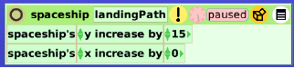  Gives students time to experiment with this script and to try positive and negative numbers. They could also choose decrease by which will give them another set of experiences.  Suggest they place the Spaceship and the Earth in different locations to explore how well they can estimate the rise over run.  The values can be set based on estimates of the ratio of rise over run and then starting the script to see how accurate the estimate was. Or the scripts can be changed while they are ticking. Experiment.  Lost spaceships can be found easily: stop the script and look in its Viewer for its x and y locations. Change the numbers to x = 100, y = 100.  Keep the project; NameEarth, e.g. KateEarth.
Lesson 2:  Script Tiles: Pen Use  Menus: Button to Fire a Script | Add a pen trail for the Spaceship.  Give students time to experiment with pen colors, sizes, and trail styles.  Give them time to experiment and develop skill in controlling the path of their spaceship.  They should be able to make their spaceship move up and to the right or left and down and move to the right or left. Give them time to see how positive and negative numbers affect motion. Discuss.  Discuss strategies.  Make a Reset script with specifying, assigning, the spaceship’s x and y location. Add a clear all pen trails tile. Name the script gameReset. Make a Button to Fire a Script.  Open a Viewer for the world and use the fill and border category to change the color of the background. Give students time to experiment.  Discuss the difference between gradient fill and radial fill.  Publish the project: nameSpaceship e.g. Kate’s Spaceship.
Lesson 3: | Expert Challenges script: In this lesson, students make a script to change the size and location of the Earth and the spaceship.  These scripts use random number generator tiles and students will need time to experiment with how much change they want to see in their project.  For example, the earth can have any x and y coordinates as can the spaceship. Students will need to decide if they want the earth to stay a particular area or can appear anywhere on the screen. This example project sets limits so that the spaceship is always to the left of the Earth. This was an arbitrary decision and others may choose otherwise.  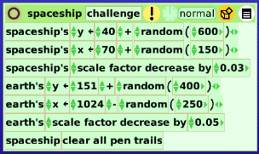  Modify the world’s Game Reset script so the spaceship size and location are specified and so are the same details for the earth.  Keep the project.
Lesson 4: | This lesson adds a canopy of stars to the background. The stars are scripted to turn when ticking and change color when under the mouse.  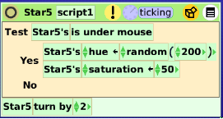  Give students time to try other students’ projects and modify their project after this experience.  Keep the project.
Lesson 5: | This lesson adds a title and directions on how to play the game.
Standards: | Common Core Standards  Mathematics: 5.OA.3; 5.NBT.3, 5.NF.3.5; 5.MD.2; 5.G.1.2  Bloom’s Taxonomy/Cognitive Domain  Knowledge: knows, selects, defines  Comprehension: classifies, estimates  Application: produces, uses, changes  Analysis: analyzes, compares, experiments  Synthesis: modifies, plans  Evaluation: investigates, compares  NETS :  1. a, c, d  2. b  3. d  4. a, b, c, d
Resources: | Etoys Help Quick Guides: always available in Etoys. Open Etoys and click the question mark to open a set of interactive tutorials of basic tools and techniques.  www.etoysillinois.org projects, lesson plans, software download  www.mste.Illinois.org more math, science, and technology resources  www.corestandards.org Common Core Standards  www.squeakland.org software and Etoys projects  www.nctm.org Standards and Focal Points for each grade level
kh January 2011

